Name: Lillian Case

Date: 10/4/22

Class: CS225U

1. Shell – Unix command processor that interprets commands and takes appropriate action

Option – proceeded by a hyphen and they modify what the command does

Standard Output – file where the program sends output

Pipe – | connect the output from one utility to the input of another

Metacharacter – another word for wildcard keyword in the Unix language \*,?,etc

Background Process – a command that continues to run while you work on another task in the foreground

Foreground Process – a command that runs on the screen in front of you

PID – Process ID Number

Tee – lets you run two commands at one time

Program – set of coded instructions contained in a file

Argument – anything that follows the command name – including the options and file names

Grave accent – ` used as a backquote

Wildcard – keywords/characters that perform actions on Unix with characters rather than the longer command

Job Number – a number in brackets assigned by Bash

Process – what you get whenever the computer runs a program

Standard Input – file where the program normally looks for input

Redirection – >,>> place a standard output into an ordinary file instead

Filter – takes a stream of data from its standard input, transforms the data in some way, and sends the results to the standard output

Quote – used for special characters so that they are not interpreted as the metacharacter, but as the character itself

Process ID number – (PID) number assigned by the shell to every process running in the background

Job Control – commands that are used for different effects (bg %, fg %, jobs, kill %n, stop %n)

1. echo \* -- prints everything in current directory

echo /\*

echo \\*

echo “\*”

echo – prints whatever you type after echo

echo \*/\*

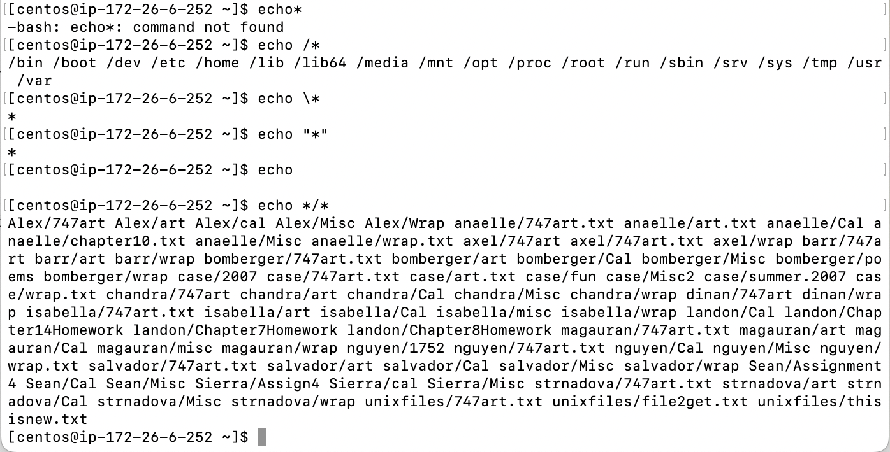

1. How would you use cat to show the contents of the files ending in *ing*?

cat \*ing

1. How would you list any files containing *x* or *X* (in this case, boxing and teamX)?

ls \* [Xx]\*

1. How would you show the contents of files with names containing *o*?

cat \*o\*

1. How would you show the contents of the files backgammon, backpacking, and blackjack using just one command?

cat b\*ack\*